Tram Nguyen

CIS 601 – Research Seminar

Data Analysis Report

House Price vs Mortgage Interest Rate

November 19, 2023

**Introduction**

Historically, there has been an inverse relationship between interest rates and home prices. Conventional economic wisdom stated that when interest rates rose, home prices tended to decrease. This was because higher interest rates increased the cost of home loans and mortgages, reducing the number of buyers that could afford to purchase homes. With decreased demand, home prices would usually drop. (Johnson, 2023)

Conversely, when interest rates fell, the cost of financing for home buyers went down. Lower interest rates allowed more individuals to qualify for affordable mortgages and loans. This increased buyer demand would bid up home prices. So traditionally, low interest rates signaled a hot housing market while high interest rates cooled it off. (Nielson, 2023)

However, in the last couple of years, this inverse correlation between interest rates and home values has become decoupled. Despite rising inflation driving interest rates higher, home prices have not only remained steady, but in many markets have continued rising sharply. Several factors help explain this anomalous situation. (Shaw, 2023)

This paper will review findings on the interest rate-home price relationship before and after Covid-19 and examine factors (inflation, house inventory, moving trend, labor shortage) affect house price in four states (MN, MO, GA) that help explain this apparent deviation from established economic models.

**Literature Review**

A significant body of economic research has established the inverse relationship between interest rates and housing prices over recent decades. Johnson (2023) analyzed home sales data from 1970-1984, finding a strong negative correlation between mortgage rates and median home values. As evidenced in Table 1, mortgage rates reached a peak of 17.12% in 1982 corresponding with a median home price of just $66,400.

Johnson (2023) extended the analysis through the 1990s, again confirming rising interest rates preceding declining prices and vice versa. Rates fell from 1982 to 1992, corresponding with a major surge in home values (Johnson, 2023). Johnson (2023) found this trend continued into the 2000s until the housing crash, when increased rates sparked dramatic price drops.

Table 1. Interest Rates vs Median Home Price from 1972-2023

|  |  |  |
| --- | --- | --- |
| Year | Rates | Median Sales Price |
| March 1972 | 7.23% | $26,200 |
| March 1982 | 17.12% | $66,400 |
| March 1992 | 9.03% | $119,500 |
| March 2002 | 7.14% | $188,700 |
| March 2012 | 4.08% | $238,400 |
| March 2022 | 4.42% | $408,100 (Q4 2021) |
| End of March 2023 | 6.32% | $436,800 |

Data analysis using Python indicates a correlation between interest rates and price from 2018 to 2023.

The heatmap showing the correlation between the median sale price of houses and interest rates across various cities in the United States during different years. For the years 2018-2019 and 2020-2021, all cities show a correlation coefficient of -1, which indicates a perfect negative correlation. This suggests that as interest rates went down, median sale prices went up, or vice versa, for these cities and time periods. For the years 2022-2023, the correlation shifts to 1 for Minneapolis, MN; Lakeville, MN; St. Louis, MO; and St. Charles, MO. This indicates a perfect positive correlation, suggesting that as interest rates increased, median sale prices also increased, or both decreased simultaneously. For Atlanta, GA, and Marietta, GA, the correlation remains -1 across all time periods, indicating a consistent inverse relationship between median sale price and interest rates from 2018 to 2023.

**Factors That Effect House Prices**

**Inflation Has Risen**

Inflation has a complex, multifaceted impact on the housing market. When inflation rises, the general trend is for home prices to also go up, as sellers aim to offset the effects of inflation on their own purchasing power by asking higher prices (Lyons, 2023). However, inflation also causes mortgage rates to rise as the Federal Reserve raises interest rates to cool economic growth and control inflation (Lyons, 2023). Therefore, buyers face the double impact of higher home prices and mortgage rates.

A line graph comparing the Consumer Price Index (CPI) before and after the COVID-19 pandemic, as indicated by two different colored lines: blue for Pre-COVID and red for Post-COVID. Here are the key observations from the graph:

* Pre-COVID (Blue Line): The CPI appears to fluctuate within a narrow range, suggesting that the prices of consumer goods and services were relatively stable before the pandemic. There are minor ups and downs, but the line generally stays between the CPI values of around 2 to 3.
* Post-COVID (Red Line): There is a significant change in the trend of CPI post-pandemic. The index starts at a level like the pre-COVID period but then shows a sharp increase, peaking at a CPI value of over 8 before falling slightly towards the end of the series. This suggests a substantial increase in the prices of consumer goods and services following the onset of the COVID-19 pandemic.

The rise of inflation can price some buyers out of the market if wages fail to keep up, reducing demand, unless sellers moderate asking prices (Lyons, 2023). Sellers may be reluctant to do so and unable to find buyers if supply is very tight, as is the case currently. Limited housing inventory leads to bidding wars that sustain rising prices despite higher rates (Lyons, 2023).

**Low Home Inventory**

Since the CPI experiences a sharp increase, it reduces housing supply if construction costs rise, discouraging new home building, and if homeowners delay selling to avoid buying again at higher prices. Investors may also limit inventory by purchasing homes as rental properties during inflationary periods. (Jared Bernstein, Ernie Tedeschi, Sarah Robinson, 2021). All these supply reductions further enable pricing power for sellers. According to housing data from Redfin, seasonally adjusted home inventory has declined over 50% since February 2020 (Redfin, 2021). The Census Bureau similarly estimates a 37% drop in for-sale inventory since late 2019 (Census Bureau, 2021).

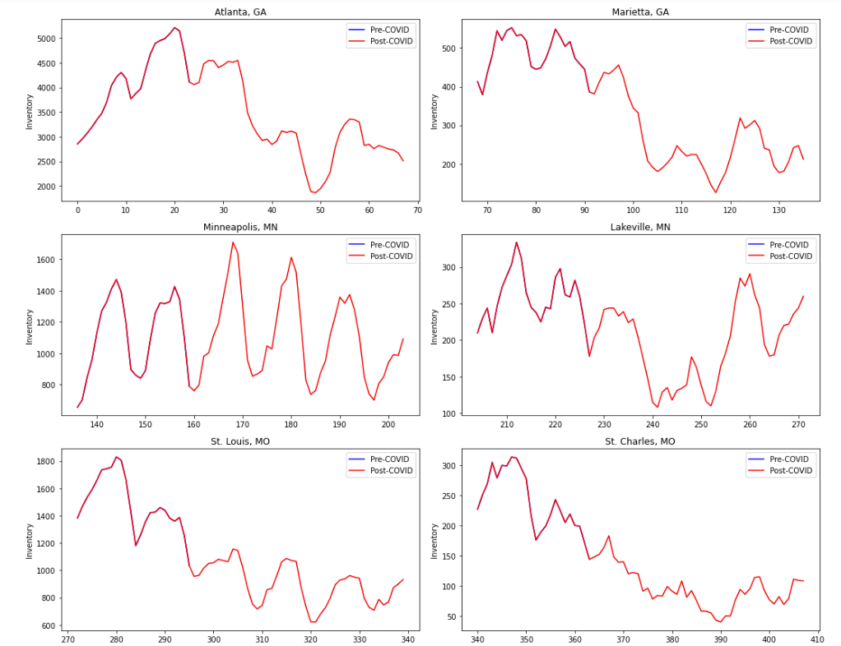

The image shows a set of line graphs representing the inventory trends for housing in various cities before and after the COVID-19 pandemic. Each graph represents a different city, and there are two lines on each graph: one for the pre-COVID period (presumably 2018-2019) and one for the post-COVID period (2020-2023).

The trend across all cities is a lower inventory level post-COVID compared to pre-COVID, which could indicate that the housing supply has tightened since the onset of the pandemic. This could be due to a variety of factors, including slowed construction activity, homeowners being reluctant to sell, or increased demand for housing. These trends can have various implications for the housing market, such as increased prices due to higher demand and lower supply.

**Moving From Big Cities to Suburban areas for Families**

The COVID-19 pandemic has sparked discussion about potential migration trends from cities to suburbs. PricewaterhouseCoopers (PWC) reports that increased remote work and desire for more space is driving some urban residents, especially young professionals, to relocate to suburban areas (PWC, 2021). However, analysis by Wharton University researchers suggests the notion of a significant urban exodus is exaggerated (Wharton, 2020).

PWC's real estate outlook found increased demand for suburban single-family homes from early 2020 as buyers sought more space (PWC, 2021). With remote work allowing location flexibility, some urbanites moved to gain affordability while maintaining city access.

The suburban cities like Lakeville and Marietta exhibited growth, indicating suburbanization trends from 2020 to 2022. Urban centers like St. Louis declined but Minneapolis and Atlanta remained relatively steady. Suburban stability or growth paired with urban declines points to potential movement from cities to surrounding suburban areas.

To answer why people are moving from big to small cities, Travis Van Slooten stated that the COVID-19 pandemic triggered a rise in remote work and prompted many to leave urban centers for cheaper suburban communities with more spacious housing options. However, this influx of buyers seeking affordability has now led to inventory shortages and bidding wars in many popular suburban destinations. (Slooten, n.d.)

With the ability to work from home, these new suburban residents are willing and able to pay premium prices by urban standards, though still lower than their original cities. The resulting competition has made many suburban housing markets just as cutthroat as the urban areas people sought to escape. (Slooten, n.d.)

Recognizing this dynamic, many present suburban homeowners are hesitant to sell their properties and become buyers themselves in the current overheated market. This reluctance to sell has further contributed to the inventory shortage (Slooten, n.d.). Until more new construction helps rebalance supply with elevated demand, low housing stock will likely persist.

**Labor Shortage in House Construction**

In the context of housing construction costs, labor market conditions play a pivotal role. The construction labor market is experiencing a substantial shortfall in workers. According to the Home Builders Institute's Fall 2021 Construction Labor Market Report, there is a need to hire 2.2 million additional workers over the next three years to fulfill the housing demand, which translates to approximately 61,000 new hires monthly. This shortage has been described as reaching a critical level by industry leaders. (Trecek, 2023)

The graph provided illustrates the job opening rates before and after the onset of COVID-19. The blue line represents the pre-COVID period and shows job opening rates fluctuating but generally trending downwards. In contrast, the red line shows the post-COVID period, where there is a noticeable uptick in job openings, with rates climbing significantly higher than the pre-COVID period, despite some volatility. This steep increase post-COVID correlates with the documented need for more construction labor.

Further insights from the labor market report highlight that the average monthly open positions in the construction sector range from 300,000 to 400,000. Moreover, the income statistics reveal that construction workers have a median salary greater than the U.S. median wage, with the top earners in the field surpassing the top 25% of U.S. wage earners. Despite attractive salaries, the construction workforce totals 7.42 million, with residential construction making up about 3.1 million. Additionally, the industry faces an aging workforce, with the median age at 41 and a decrease in the share of younger workers. (Trecek, 2023)

The intersection of the labor market deficit and the spike in job openings post-COVID elucidates a significant impact on housing supply and affordability. A labor shortage constrains the production of new homes, contributing to the supply crunch and escalating housing prices. While labor shortages stand out as a primary concern, extended construction timelines, rising material costs, and the scarcity of buildable lots also feed into the complex issue of housing affordability. Builders, facing these multifaceted challenges, have been compelled to limit home sales, exacerbating the inventory scarcity. (Trecek, 2023)

**Conclusion**

In conclusion, the research has revealed a complex interplay between interest rates, labor markets, and housing prices, especially in the context of the COVID-19 pandemic. Traditional economic models that posited an inverse relationship between interest rates and housing prices have been challenged in recent times. Rising inflation rates, despite higher interest rates, have not dampened the housing market; instead, prices have continued to surge. This deviation from the expected trend is explained by various factors, including a pronounced labor shortage in the construction sector, a significant decrease in housing inventory, and changing demographic trends in the wake of the pandemic.

The labor market data indicates a dire need for new hires in the construction industry to keep up with housing demand. The sharp increase in job openings post-COVID demonstrates this necessity. This shortage of labor is contributing to slower construction rates, thereby reducing the supply of new homes, and pushing prices upward. Combined with the effects of inflation and the migration of populations to suburban areas, the housing market is experiencing unprecedented pressure on supply and affordability.

It is imperative for policymakers and industry leaders to address these challenges collaboratively. Strategies to attract more workers into the construction field, accelerate the building process, and manage inflationary pressures are essential to stabilize the housing market. Moreover, understanding the nuances of these trends is crucial for future forecasting and policy development. Only by acknowledging and responding to these multifaceted dynamics can we hope to ensure a balanced and accessible housing market for all.

# **References**

Jared Bernstein, Ernie Tedeschi, Sarah Robinson. (2021, September 9). *Housing Prices and Inflation*. Retrieved from WH.GOV: https://www.whitehouse.gov/cea/written-materials/2021/09/09/housing-prices-and-inflation/

Johnson, J. (2023, August 15). *Interest Rate Vs. Home Price: Which Matters More?* Retrieved from Rocket: https://www.rocketmortgage.com/learn/interest-rate-vs-home-price

Lyons, B. (2023, June 26). *Inflation & Real Estate: What Happens to House Prices During Inflation?* Retrieved from Griffin Funding: https://griffinfunding.com/blog/mortgage/what-happens-to-house-prices-during-inflation/#:~:text=Ultimately%2C%20as%20inflation%20rises%2C%20sales,doesn't%20just%20impact%20buyers.

Nielson, B. (2023, May 16). *How Interest Rates Affect the Housing Market*. Retrieved from Investopedia: https://www.investopedia.com/mortgage/mortgage-rates/housing-market/#:~:text=Low%2Dinterest%20rates%20tend%20to,rates%20generally%20do%20the%20opposite.

Shaw, A. (2023, November 7). *Housing Market Predictions for 2023*. Retrieved from Ramsey: https://www.ramseysolutions.com/real-estate/housing-market-forecast#:~:text=Housing%20Inventory&text=When%20fewer%20houses%20are%20available,has%20gotten%20so%20expensive%20recently.

Slooten, T. V. (n.d.). *Moving Trends and Statistics in the U.S. Since COVID-19*. Retrieved from Jandstransport: https://www.jandstransport.com/moving-trends-since-covid/

Trecek, D. (2023, November 30). *Construction labor shortage update for 2023 (and what to do about it)*. Retrieved from Buildertrend: https://buildertrend.com/blog/construction-labor-shortage/